2019 Spring Newsletter
Couple photo on page 1, with caption. Autobiography wraps from page 1 onto page 3, with Heritage Dinner poster. Passport photo on page 3 (to connect the front page story with the scavenger hunt article). Upcoming
Events also on page 1 as usual.
For 45 years, our museum has told the immigration story.
The museum commemorates the Russian immigrant families and their new beginnings in Marion County. Heinrich B. Friesen was born in 1837 in Chortiza Colony, So. Russia. After his marriage to Helena Duerksen in 1859, they lived in Alexanderthal, Molotschna Colony, So. Russia. Excerpts from the H.B. Friesen 1837-1927 autobiography provide a window into his family’s long journey from Russia to Kansas in 1879, five years after the Alexanderwohl immigration:
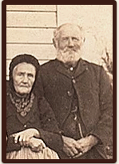
"Everything was ready now. All arrangements had been made for the trip on the railroad and the ship. . . We counted the days and finally it came when we had to part from the place where we… had experienced so much love; never to see it again. Almost all neighbors from the village came to say goodbye. It hurts to part. This we experienced as the last handshake and kiss were given.

Caption: H.B. Friesen and wife Helena (Duerksen) Friesen
circa 1917. H.B. Friesen was an uncle to the museum director’s
maternal grandmother.

"We were a big family and had made the following arrangement. David was three weeks old when we started. I had had a light cradle of tin made for him. This I carried and went first into the railroad car and set it on the first bench, indicating that this would be our place. Then followed Cornelius [age 19] with Justina who was two years old but could not walk yet, so had to be carried. Then followed Bernhard [age 17] with a basket of cups and utensils which we would need for eating on the journey. Then followed Helena [age 11] and Heinrich [age 9] who each had to carry something. David and Gerhard [H. B.'s wife's mentally handicapped brothers] had to carry a trunk made of tin filled with things to eat, holding on to each end of the trunk, with Anna [age 6] leading them. Mother [H.B.'s wife Helena (Duerksen)] was at the end of the row.
"The Russian railroad cars were not very comfortable. They had seats with backs to them but the cars were so full that there was no room for sleeping. The small children were put under the benches for sleeping. The rest of us had to get along with sleeping as well as we could even in a sitting position. The most difficult part of the journey was when we had to change trains at night when everyone was sleeping. The journey was more difficult than we had imagined but with the Lord's help we overcame all difficulties.
They reached the city of Antwerp, the capital of Belgium. The ship they were scheduled to board had to leave before the group arrived. This caused a delay of five days. He wrote about passing the time by watching a carnival in the street with young and old wearing their wooden shoes on the paved street that made a big clattering noise. There were many women there, too, and they danced and shouted in a big empty space. "We were satisfied to stay a ways off.” They went to a museum in the morning and then another in the afternoon, where they saw prehistoric animals that lived before the flood. His story continues at the ship.
"Monday we got onto the ship named Switzerland and Tuesday when we woke we were on the way between Holland and Belgium. . . .We then entered the English Channel and here the ship began to rock back and forth. Soon passengers went to the side of the ship, ‘to pay tribute to the ocean.’ . . . The sea often was as quiet as if covered by ice. As a result, our family did not suffer from sea sickness although some close to us were bothered with it throughout the trip. Often we could see large numbers of fish following and swimming around the ship.
"We were 16 days on the ship... we arrived at the Delaware River. . . it felt good to have solid ground under the feet again. [June 24, 1879].
“In America, the trains go at such a furious pace that a person going along the aisle of the car has to hold on to the seats along the way to keep from falling from one side to the other. . . We went through a number of towns and about sundown came to our last station, Peabody.
“Before the train stopped we already saw our brothers, sisters, and friends who had come to welcome us and to take us to their homes. The welcome, after five years of absence, was from the heart, with love. What we felt, I cannot adequately describe. Only those who have experienced it can know.”

Upcoming Events: Heritage Fundraiser Dinner at Alexanderwohl Mennonite Church. March 15, at 6:30 pm. Our featured speaker will be KWCH Melissa Scheffler. 3rd Annual Art Show in spring, Car Show & Sidewalk Sale June 15, Threshing Days August 2-4. Second Monday Family History & Genealogy Group: March—Bob Schroeder, Orphan Train; April—Don and Eleanor Stutzman, Catlin Cemetery; May—J. Harvey Koehn, trip to Poland; June—Sea-Going Cowboys; July—Ilona Abrahams, the Goessel Alumni Association. Museum Hours: See pg 4 for our Spring hours
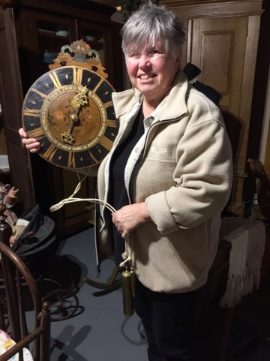
Dit unt Daut Page 2
In 1974, the museum’s founders created spaces for families to save some items their ancestors brought from Russia. Of the thirty-some showcases, more than half have artifacts that are specifically identified as such. When you leave the only home you know, what do you take and what do you leave behind? On the Kansas prairie back then, there was no Walmart. You had to make do with what you brought or what you could borrow from neighbors. Immigrating as a large group was very advantageous.
This recently-donated clock, dated 1822, made the journey from Russia to Kansas. How many Russian clocks will you find at the museum?
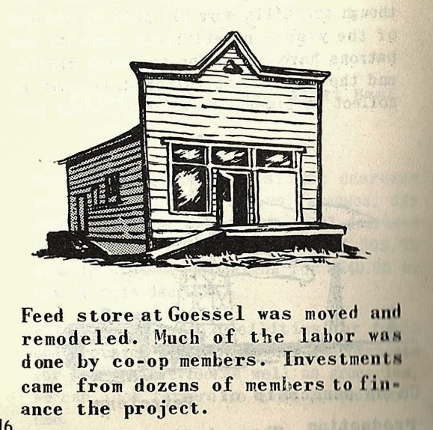
Thinking of something fun for the museum, my thoughts turned to emigration from Russia, and I created the Russian Passport Scavenger Hunt. The hunt will be available throughout 2019 and is free for museum members; nonmembers $4 for each passport plus regular admission. Families or small groups can work together to complete the challenge! Optional souvenir passports will be available for purchase. I must make it clear that, while this scavenger hunt is based on real artifacts, stories, and photos from the Goessel Mennonite community, it was assembled as historical fiction.
On another topic, I have been working along with Mayleen Thiesen Vinson (who manages our Facebook page), looking at past Goessel businesses and where they were located. Ilona Abrahams and Jerry Toews have also expressed interest in this topic. I have begun making a timeline using old Goessel telephone books; the earliest is from 1913. The sad thing is, since everybody knew where the businesses were, no addresses were given for them! Please bring in photos you have to share or information about past businesses in Goessel. The search is ongoing!
Caption: From the 1952 Crossroads Co-op Association Annual Report

The museum’s annual meeting was held on January 20, 2019. About 80 people enjoyed hearing Brian Stucky’s program on the Cherokee Trail. Volunteers were recognized. New museum board members are Roger Bartel and Myron Goertzen, and Ladene Herrick has been appointed to fill an open position. Both Jim and Connie Wiens were reelected to the board. Faspa was enjoyed after the program. Page 2 (Add new board members to the front page list, please!)

Fern’s favorite Plautdietsch tongue twister: “Feftijch Fata Fruess Frate Freestikj“ English translation: Fifty fat women devour breakfast. (Ask Fern to say it!) Page 2

Page 3 BUT DO use this one with the right DATE!!!!

Page 3 with the overflow from article from page 1
Back page, use last year’s membership form. Change the heading to: Renew Your Annual Museum Membership or Become a New Member!
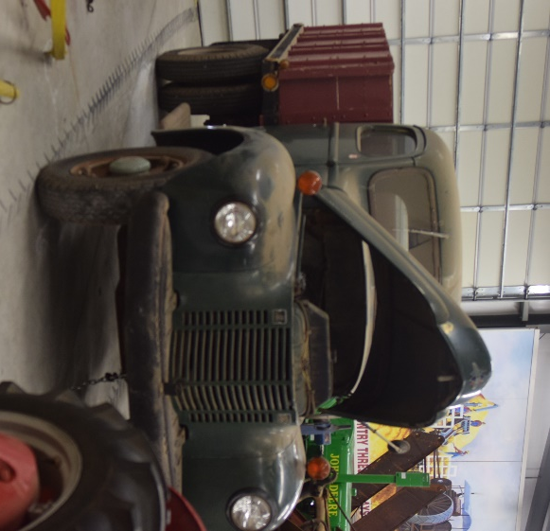

1945 International Grain Truck is now
on display at the Wheat Palace. Use if need to
fill space

